2. Turtles
2.1 Track counts
There are no less than 52 beaches in and around the atoll that turtles utilize for nesting purposes (Mortimer 1996). Variability in the nesting frequency between these beaches has called for the prioritization of track count efforts to favour high nesting frequency beaches. Furthermore, some beaches are more accessible than others and can therefore be surveyed more often. Beaches 47 (settlement beach) and beaches 1-22 (West Grande Terre) have been surveyed most often as they exhibit both high nesting frequency and easy accessibility. Other beaches around the atoll (with the exception of some remote lagoon and Grande Terre beaches) were surveyed on a monthly basis. In addition, opportunistic counts were conducted were possible.

According to Dr. Mortimer’s guidelines (Mortimer 1996), some beaches were not surveyed as often as they should have been this year. These beaches include some lagoon locations and remote areas on Grande Terre. In addition, in some months the West Grande Terre beaches were not surveyed often enough. This is partly due to the fact that no counts are conducted from the boat anymore and that more time (i.e. more favourable tides) was required to fulfil the monthly requirements. An increase in new monitoring activities this year resulted in the allocation of some of the good morning tides to other activities. All efforts will be made in the future to stay on schedule with track counts. Perhaps more overnight trips to Anse Mais should be planned.

Whilst analysing this data, it became evident that the nestability of beaches was not recorded adequately. At the beginning of the year it was attempted to introduce a new system whereby each beach is rated according to its nestability. However, this practice was abandoned due to the high degree of observer objectivity. Subsequently, obsolete beaches were not entered correctly as there was some uncertainty regarding the point at which a beach is termed ‘obsolete’. This issue will be dealt with during the next training session with the rangers.

The number of tracks counted per beach in 2003 was divided by the number of track counts conducted in order to award a nesting activity factor to each beach around the atoll. The 20 beaches showing the highest nesting activity are presented in descending order in figure1.
Track counts per region are further described in this chapter.

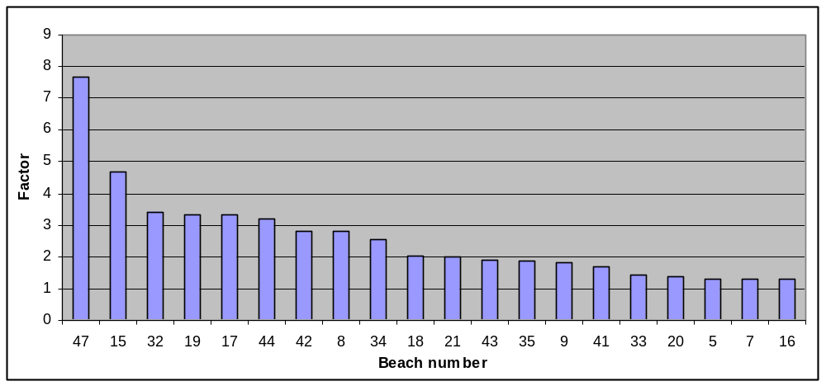
Figure 1: Index nesting activity on the 20 most visited beaches around the atoll between January and November 2003

2.1.1 Settlement beach (beach 47)
A total 159 counts were conducted between January and November this year (table 1).

Nesting seasonality has not followed the typical bi-modal pattern. The typical pattern includes a peak in February to March followed by a predominating peak in June to September (Mortimer et al, in press & Liljevik 2002). Nesting activity on the settlement beach this year peaked during February and April, however the predominant peak in June to September was nonexistent (figure 2&3). Indeed, the third lowest mean score of monthly tracks was recorded in September.

Table 1: The number of track counts, mean number of tracks (VF), standard deviation and 95% confidence intervals per month for the settlement beach
Month | Number of counts | Mean number of tracks | SD | 95% C.I
January | 11 | 5.3 | 3.23 | 1.91
February | 14 | 12.8 | 7.93 | 4.15
March | 7 | 14.3 | 4.39 | 3.25
April | 10 | 14.5 | 7.35 | 4.56
May | 20 | 12.7 | 5.98 | 2.62
June | 17 | 9.4 | 4.36 | 2.07
July | 18 | 7 | 4.40 | 2.03
August | 16 | 4.3 | 2.98 | 1.46
September | 21 | 2.7 | 1.73 | 0.74
October | 15 | 2.5 | 1.46 | 0.74
November | 10 | 2.6 | 0.97 | 0.60

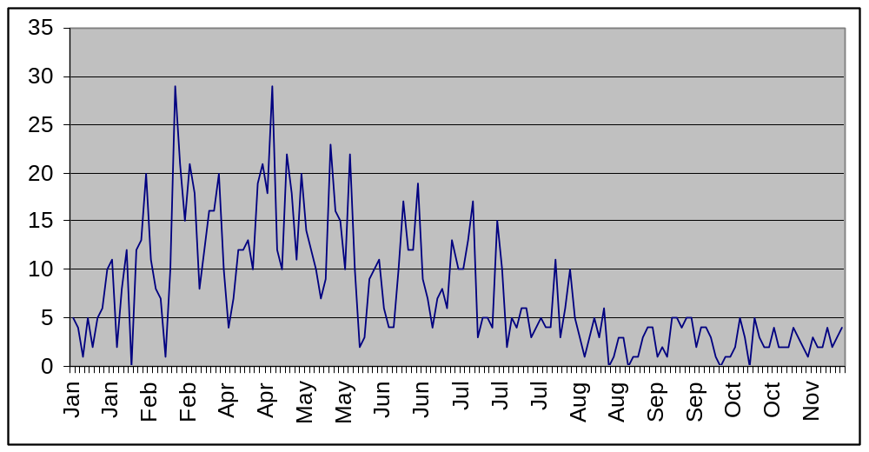
Figure 2: The number of ‘very fresh’ tracks per survey along the settlement beach between January and November 2003

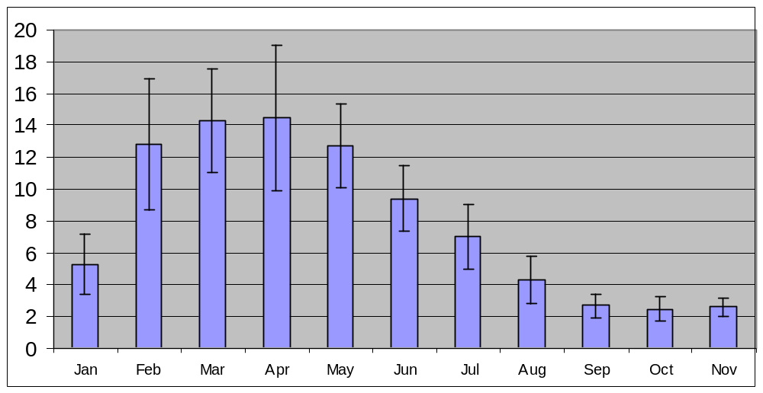
Figure 3: Mean number of ‘very fresh’ tracks per month with 95% confidence intervals for the settlement beach between January and November 2003.

2.1.2 West Grande Terre region (beaches 1-22)
Thirty-five track counts were conducted between beach 2 and 21 in the period January to November2003. All track counts were conducted on foot. Unfortunately, in some months the requested number of four surveys could not be conducted (table 2). Walking the beaches requires some time and therefore good tides. Unfortunately good morning tides are in high demand for camping trips and other monitoring programs around the atoll and have to be utilized carefully (see monitoring schedules –appendix 1). The month of August was hampered by a combination of poor tides and very rough seas (impossible to disembark on beach).

Beaches 1 and 22 have both been disregarded during counts this year as both beaches are unsuitable for nesting. Both beaches were checked on several occasions just to make sure.

Similarly to the settlement beach, no bi-modal distribution of nesting activity was evident. Statistical significance between months varies greatly; however, it is clearly evident that no June to September peak is apparent (figure 3&4).

Table 2: The number of track counts, mean number of tracks (VF), standard deviation and 95% confidence intervals per month for the West Grande Terre beaches
Month | Number of counts | Mean number of tracks | SD | 95% C.I.
January | 4 | 41.7 | 27.219784 | 26.674882
February | 2 | 83 | 25.455844 | 35.27933
March | 2 | 85 | 48.083261 | 66.638735
April | 4 | 83 | 6.4807407 | 6.3510053
May | 2 | 124 | 22.627417 | 31.359405
June | 4 | 113 | 35.292823 | 34.58631
July | 4 | 118 | 26.362853 | 25.835105
August | 1 | 54 | NA | NA
September | 6 | 68 | 29.482198 | 23.590224
October | 2 | 72.5 | 14.849242 | 20.579609
November | 4 | 38 | 12.832251 | 12.575367

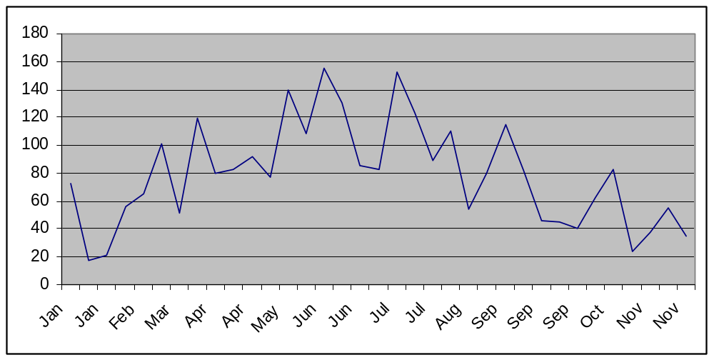
Figure 3b: The number of ‘very fresh’ tracks per survey along the West Grande Terre beaches between January and November 2003

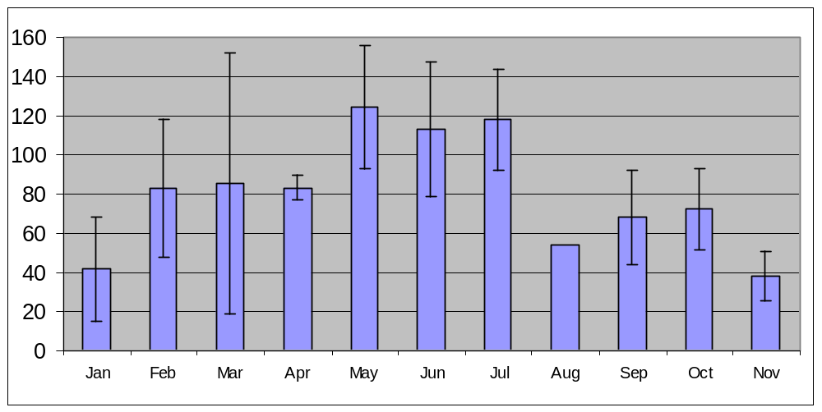
Figure 4: Mean number of ‘very fresh’ tracks per month with 95% confidence intervals for West Grande Terre beaches between January and November 2003

2.1.3 The North coast region (beaches 40-46 & 51)
The beach at Anse Cedres (40) is remote and was therefore not regularly visited.

Beaches 41 to 43 (around Anse Malabar) were surveyed most often and the sum of nests on these three beaches is presented per month in figure 5. In this case, a bi-modal pattern seems to be evident with peaks in April and August.

The Anse Var beach (unnumbered) has remained obsolete for the majority of the year and as a result, no fresh tracks were recorded during the 7 counts.

Table 3: The number of track counts and the resultant number of tracks (VF) along the North coast beaches for the period January to November 2003
Beach number | Number of track counts | Number of tracks
40 | 3 | 21
51 | 14 | 4
41 | 24 | 40
42 | 24 | 68
43 | 24 | 46
43.5 | 12 | 11
44 | 16 | 51
45 | 16 | 9
46 | 16 | 19

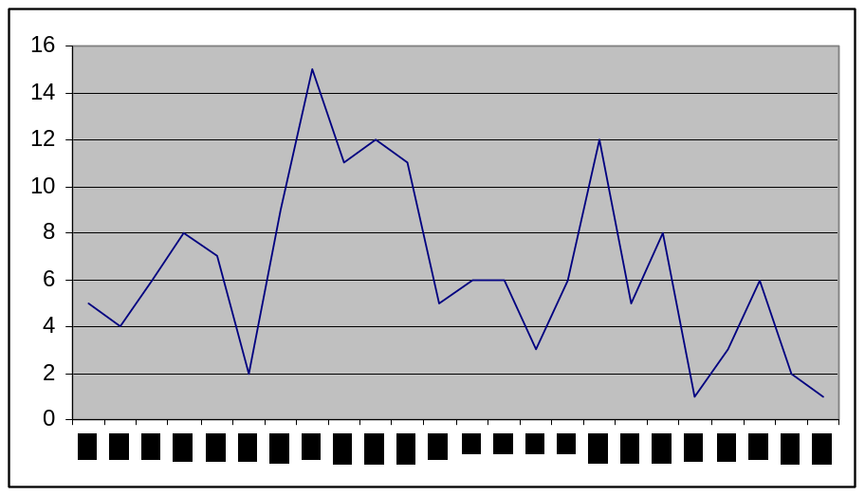
Figure 5: The number of tracks (VF) per survey along beaches 41-43 between January and November 2003

2.1.4 The south Coast region
The highest nesting frequency was recorded around Dune Jean Louis (30-36).

Table 4: The number of track counts and the resultant number of tracks (VF) along the South coast beaches for the period January to November 2003
Beach number | Number of track counts | Number of tracks
23 | 8 | 10
24 | 9 | 0
25 | 10 | 1
26 | 14 | 7
27 | 9 | 1
28 | 9 | 6
29 | 9 | 0
30 | 9 | 19
31 | 11 | 8
32 | 16 | 55
33 | 14 | 20
34 | 14 | 36
35 | 14 | 26
36 | 14 | 14
37 | 12 | 0
38 | 13 | 5
38.5 | 13 | 2
39 | 13 | 1
2.1.5 The Lagoon beaches –Hawksbill tracks
Very few hawksbill tracks were counted on lagoon beaches this year. The last track observed before the end of the 2002-2003 season was in April. During October, an old track (too old to qualify as ‘fairly fresh’) was found on beach 49a marking the commencement of the new Hawksbill nesting season. However, no new tracks were recorded in November.

Table 5: The number of track counts and the resultant number of tracks (VF&FF) along the lagoon beaches for the period January to November 2003
Beach number | Number of track counts | Number of tracks
48a | 12 | 1
48b | 12 | 0
48c | 12 | 0
48d | 12 | 0
49a | 13 | 1
49b | 10 | 0
49c | 11 | 0
49d | 11 | 2
50a | 11 | 0
50b | 10 | 1
50c | 11 | 1
50d | 4 | 0
50e | 4 | 0
51 | 14 | 2
52 | 2 | 0
53 | 0 | 0
54 | 2 | 0

2.1.6 Recommendations
- Track counts should always be conducted on foot. In cases were it is not possible to disembark the boat and where there is any degree of uncertainty regarding the freshness of tracks, counts should be abandoned (as suggested by Dr. Mortimer)
- In the future, a greater effort will be made to conduct a minimum of four counts per month on the West Grande Terre beaches.
- The ‘freshness’ of Hawksbill tracks in the lagoon should be disregarded. Nesting frequency is low enough to warrant the recording of all tracks irrespective of freshness. However, this can only be done if counts are conducted on a strict monthly basis and if all tracks are clearly ‘crossed’ in the sand indicating that they have been counted. This is subject to the approval of Dr. Mortimer.

2.2 Turtle tagging
2.2.1 Nesting green turtles
A total of 241 nesting green turtles were encountered between January and November 2003. This figure might have been much larger if the June to September peak had in fact occurred. Of the encountered turtles, 62 were already tagged. Of the 62 encounters with tagged turtles, 30 were tagged in previous seasons. A complete list of the 30 old tags is presented in appendix 2.

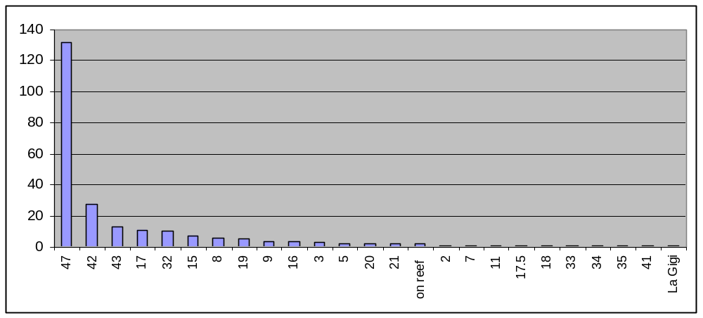
Figure 6: The number of nesting green turtles tagged per beach between January and November 2003

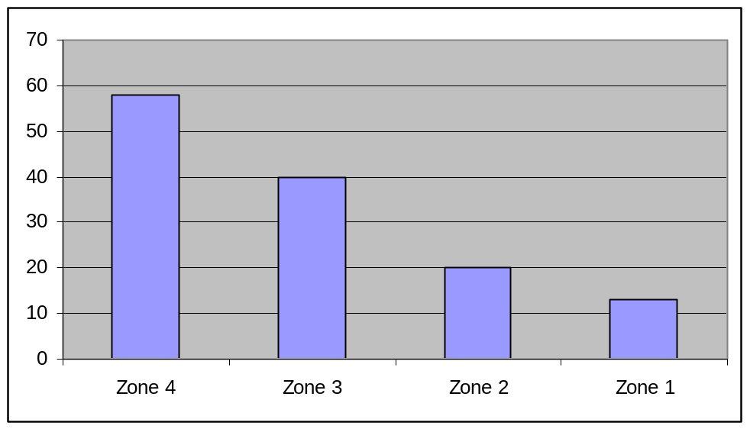
Figure 7: The number of nesting green turtles tagged in the various zones of the settlement beach (47) between January and November 2003

A total of 28 turtles were seen more than once. Turtle SEY5881 was observed attempting to nest 4 times this year. Most turtles that were observed on separate occasions were found in the proximity of their first location. Exceptions to this are SEY5847 which was observed both at the settlement beach and at Anse Malabar and SEY5808 which was seen at the settlement beach and beach 17 at West Grande Terre.

Only 7 turtles with tag scars were recorded (turtles that have lost their tags), five of these had tags on the opposing flipper meaning that the identity of only two turtles was lost.

The largest turtle measured this year was found at West Grande Terre and measured 127cm across the carapace (tip to tip). Mean morphometric measurements were calculated at:
- Over the curve –tip to tip =110.5cm
- Over the curve –mid to tip =108.7cm
- Over the curve –mid =108.2cm
- Over the curve –width =102.8cm
The accuracy and consistency of measurements taken by research staff was investigated by comparing morphometric measurements of re-sighted turtles. A variation of a few millimetres (rarely more than a centimetre) was usually found, especially between the various recorders. The morphometric measurement accounting for the highest degree of variation was carapace width. In the future, occasional tagging excursions will be conducted with the entire research team in order to compare measurements and ‘brush up’ on accuracy.

2.2.2 Tagging of immature green turtles in the lagoon
In-water turtle tagging focused exclusively on juvenile green turtles this year. Dr. Mortimer indicated at the beginning of the year that sufficient morphometric data had been collected for the hawksbill turtle. In previous years, Dr. Mortimer and the rangers tagged numerous juvenile green turtles at various locations in the west end of the atoll. It was requested that we concentrate our efforts in these areas in an attempt to recapture as many tagged individuals as possible and to tag all captured, untagged turtles.
Altogether 135 green turtles were captured, weighed, measured, tagged and sampled for DNA (table 6). Of the 25 ‘already tagged’ turtles, 9 were tagged in previous years, tag numbers are displayed in appendix 2. The remaining 16 were tagged and recaptured this year.

Table 6: The number of handled juvenile green turtles between January and November 2003
Location | Total handled | New tags | Already tagged
Bra De Cedres | 4 | 4 | 0
Ile Esprit | 55 | 48 | 7
Ile Moustique | 75 | 57 | 18
Passé Dubois | 1 | 1 | 0
Totals | 135 | 110 | 25

As for the nesting turtles, some variation in the measurements of recaptured individuals was found. As was expected, variation was slightly higher than in nesting turtles (smaller measurements); however, much variation may also be attributed to growth as younger turtles appear to grow relatively rapidly.

The scatter graph below (figure 8) depicts carapace length (Over-the-curve, tip to tip) against weight. No turtles smaller than 34cm carapace length and lighter than 4kg were found. A backward projection of a logarithmic trend line best describes the growth/weight relationship in juvenile turtles. It seems likely that rapid carapace growth (in relation to the gain in body weight) is achieved after hatching. This means that, in the hatchling stage, all energy is put into the rapid gain in size (not weight). This growth scheme seems effective as it can safely be stated that carapace size is inversely related to the abundance and of species predating on young turtles.

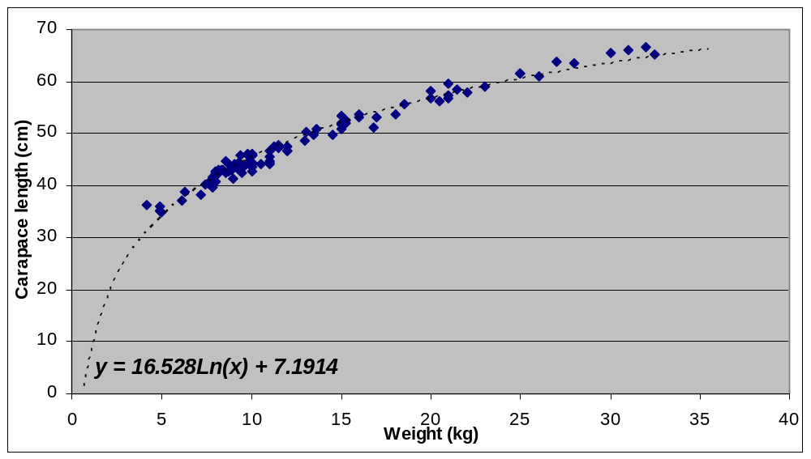
Figure 8: Carapace length (OCCL-TtT) versus weight in juvenile green turtles captured around Ile Moustique and Ile Esprit between January and October 2003. The dotted line represents the logarithmic trend line.

2.3 Turtle deaths
No less than 23 dead turtles were found around the atoll (table 7). Most of these turtles were females that died as a result of nesting activities. The most common causes of death are sun exposure, injury from collisions with champignon and falling off ledges to land on their backs.
Table 7: Dead turtles found around the atoll between January and November 2003
Date | Beach | Reason for death | Tags?
6-Jan | 33 | Dead on beach facing away from sea, died on way up! | no
4-Feb | 33 | Turtle dead on beach facing the sea, maybe exhaustion | no
20-Feb | 39 | Lying dead where champignon meets the nesting platform on the inland side. Therefore appears to have been trapped and desiccated by the sun | no
22-Feb | 29 | 2 turtles found dead next to each other on the champignon a few meters from high tide mark. Possibly a mating pair washed up and smashed up during copulation. | no
22-Feb | 32 | Turtle dead on champignon on northern side of nesting platform. Must have wandered during nesting and attempted re-entering the sea over the champignon | no
11-Apr | 45 | Fell of low champignon and landed on its back | no
5-May | 44 | Fell of low champignon and landed on its back | no
5-May | 40 | Fell of low champignon and landed on its back | no
5-May | 40 | Fell of low champignon and landed on its back | no
14-May | 36 | Dead on beach facing the sea. | no
9-Jun | 42 | Fell of low champignon and landed on its back | no
9-Jun | 41 | Fell of low champignon and landed on its back | no
11-Jun | 40 | Unknown death. Dead on beach, quite old | no
29-Jul | 34 | Climbed over log and landed on back | no
30-Jul | 31 | Smashed on champignon | no
30-Jul | 28 | Smashed on champignon | no
30-Jul | 27 | Smashed on champignon | no
30-Jul | 29 | Smashed on champignon | no
27-Aug | 35 | Smashed on champignon | no
2-Sep | 21 | Got stuck between champignon ridge | no
14-Sep | 8 | Fell of low champignon and landed on its back | no
17-Sep | 4 | Fell of low champignon and landed on its back | no
2.4 Temperature loggers
In all, 18 temperature loggers were received from Dr. Mortimer this year in order to log sand and nest temperature. Eight temperature loggers were buried at a depth of 1 meter at 4 locations around the atoll in order to observe long term, seasonal and spatial variation in sand temperature (table 8). A further 7 loggers were placed into green turtle nests during egg deposition with the aim of determining variability in nest temperature. The removal of the nest temperature loggers was scheduled to coincide with hatching, whereas the removal of the long term sand temperature loggers was scheduled for a much later date.
In previous years, some loggers were lost as they were not marked with enough care. Fortunately, 2 of these loggers were found by coincidence and were sent back to Mahe for analysis (only one remains to be found). In order to prevent any further losses of loggers, a ‘fool-proof’ method using a surface buoy and metal dropper was developed. Loggers were attached to a metal dropper with a piece of rope. The location of the dropper was marked by a buoy on the surface of the sand (figure 9). This method allowed for the free movement of other turtles around the logger site in order to facilitate normal conditions. Over the duration that the loggers were underground, turtles only succeeded in moving the position of the buoy and as the buoy was attached firmly to the dropper, no loggers were lost this year.
For the nest temperature loggers, various observations regarding nest characteristics, egg batch success and the content of un-hatched eggs were recorded. A complete account of each nest is provided in appendix 3.
Table 8: Temperature loggers used in 2003
Logger # | Used for | Date inserted | Date removed
UAB312 | Nest temperature | 7/4/2003 | 9/13/2003
UAB308 | Nest temperature | 7/7/2003 | 9/13/2003
UAB305 | Nest temperature | 7/19/2003 | 9/29/2003
UAB256 | Nest temperature | 7/19/2003 | 9/28/2003
UAB313 | Nest temperature | 8/19/2003 | 10/24/2003
UAB311 | Nest temperature | 8/20/2003 | 9/25/2003
UAB309 | Nest temperature | 9/29/2003 | 12/8/2003
UAB114 | Sand temp (Malabar) | 5/5/2003 | 11/5/2003
UAB115 | Sand temp (Malabar) | 5/5/2003 | 11/5/2003
UAB106 | Sand temp (DJL) | 5/15/2003 | 11/10/2003
UAB105 | Sand temp (DJL) | 5/15/2003 | 11/10/2003
UAB??? | Sand temp (Picard) | 5/1/2003 | not yet
UAB??? | Sand temp (Picard) | 5/1/2003 | not yet
UAB??? | Sand temp (Anse Mais) | 5/27/2003 | not yet
UAB??? | Sand temp (Anse Mais) | 5/27/2003 | not yet
UAB300 | Not used yet | xxxx | xxxx
UAB310 | Not used yet | xxxx | xxxx
UAB315 | Not used yet | xxxx | xxxx

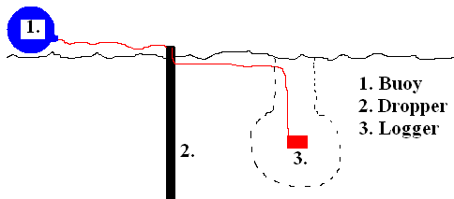
Figure 9: The buoy and pole method of marking the location of temperature loggers

